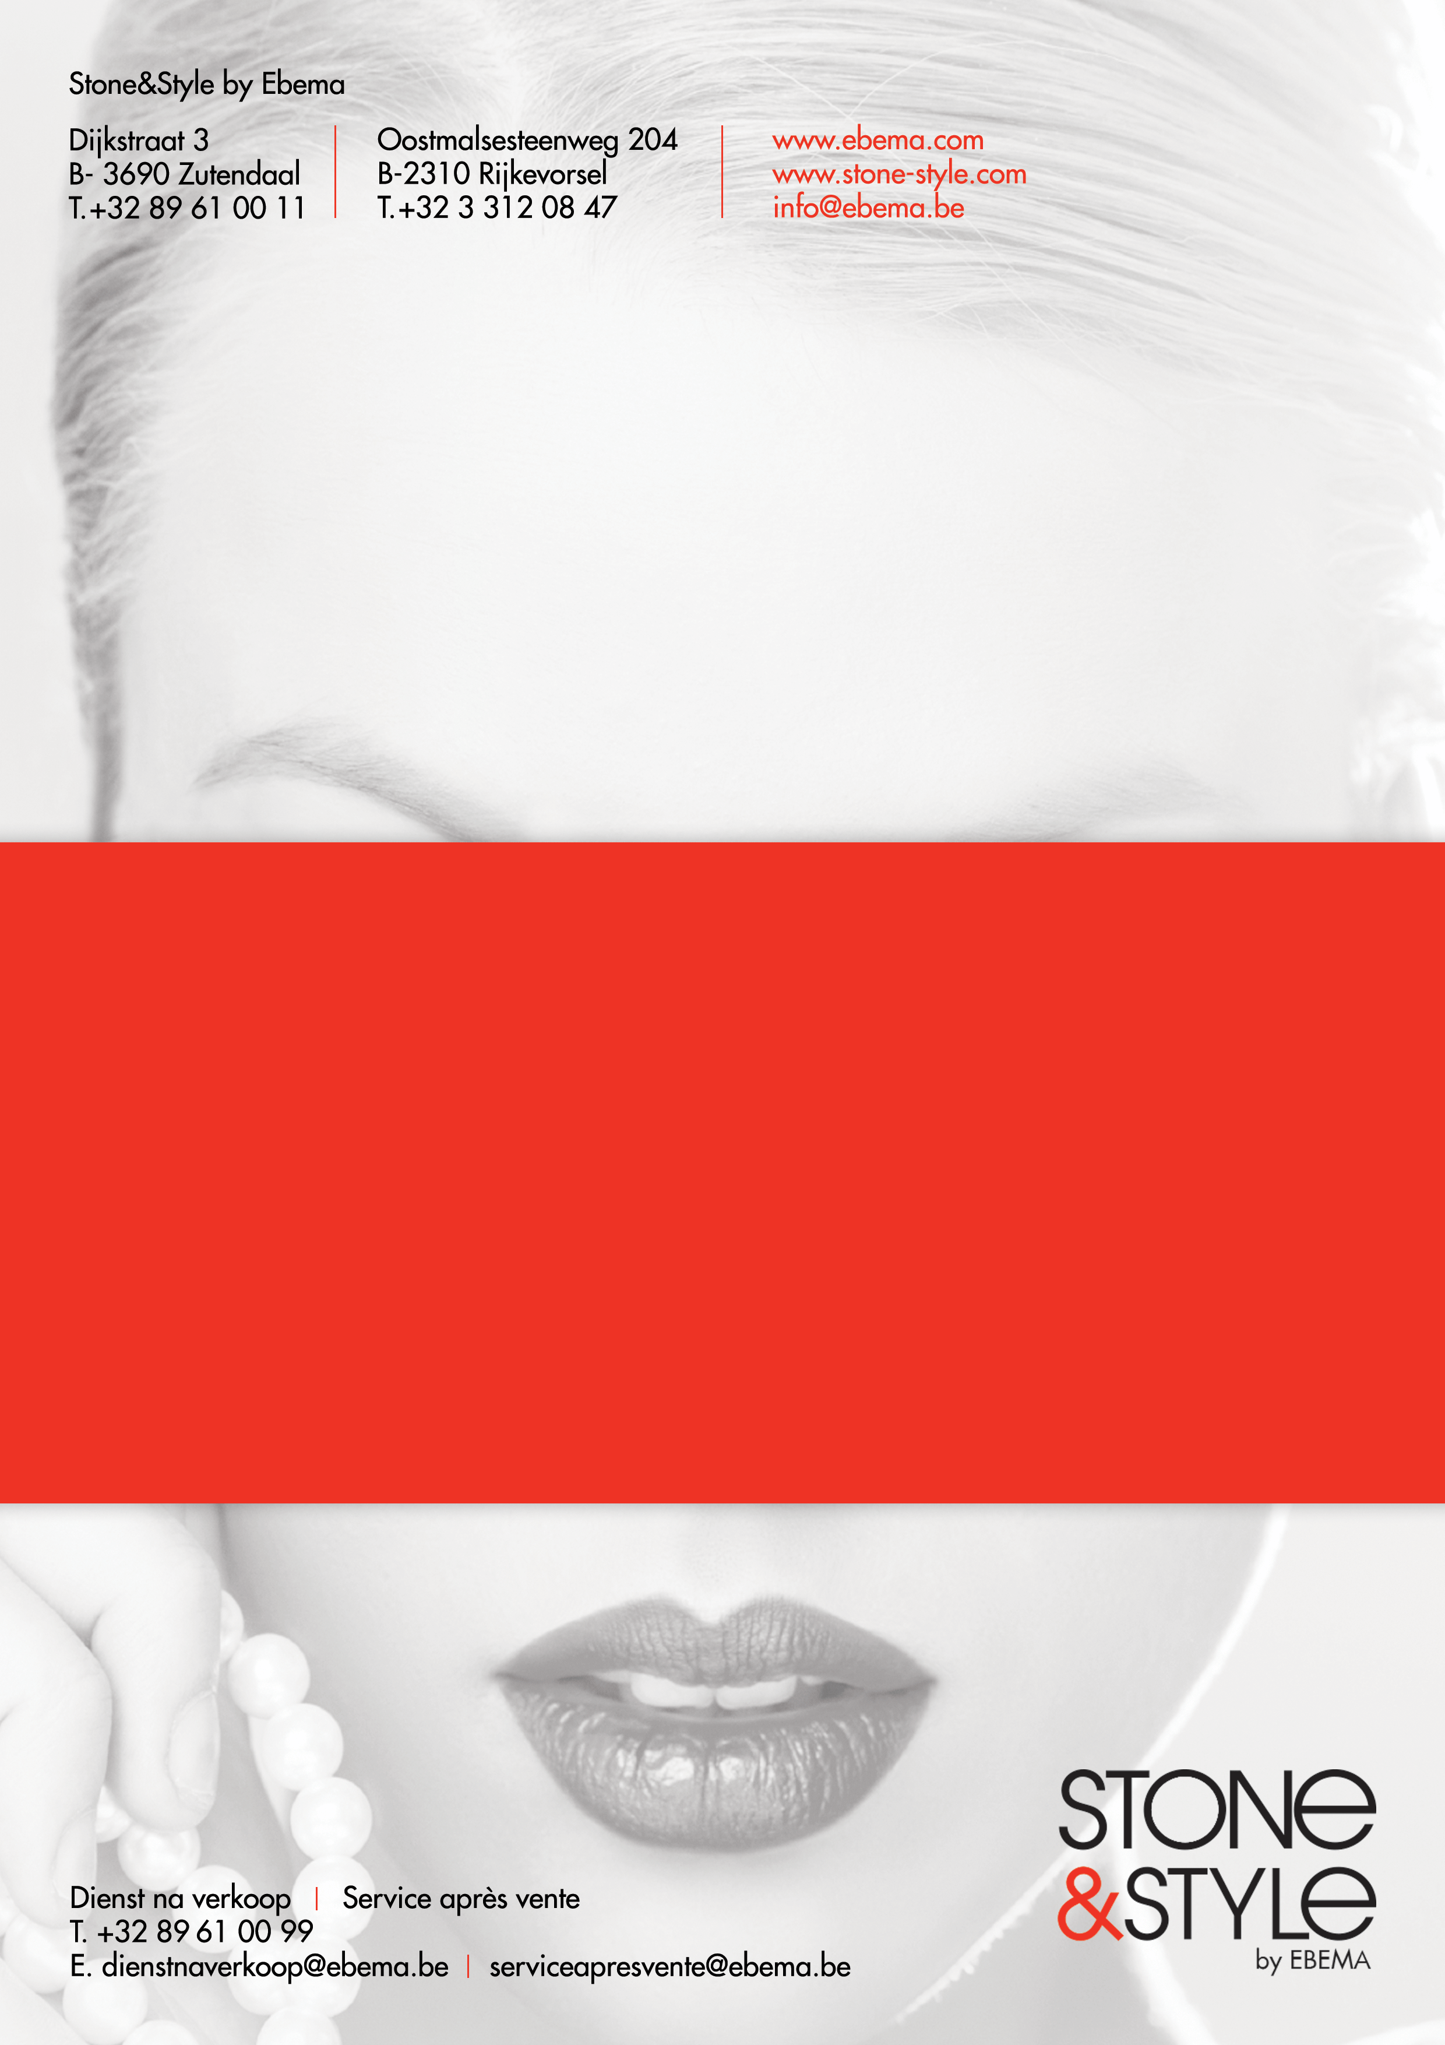
INFO SHEET EB001
Cleaning and maintenance of concrete paving slabs and concrete pavers

Table of contents

1. General cleaning 3
2. The surface of a concrete product up close 4
3. External contamination during or after installation 5
4. Oil stains 5
5. Grease stains 5
6. Other stains 5
7. Green deposits 6
8. Lichens 7
9. White spots: Efflorescence? 8
10. Cleaning agents summary table 9
11. Frost resistance 9
12. Preventative treatment 10
13. Maintenance of Mega Smooth products 11

Thank you for choosing quality products from Stone & Style for the construction of your driveway, patio or garden. We would like to make some recommendations to ensure that you can enjoy your new concrete paving for many years to come.

- General cleaning

All you have to do to keep the concrete paving looking beautiful is to brush it regularly and rinse it with water occasionally.
Normal dirt on pavers and tiles can usualy be removed with a hard brush, with or without clean water.
For stubborn stains, we recommend using a, commercially available, neutral detergent (for green deposits, oil and grease stains, ... see below).
To make drives and terraces look as good as new after thorough cleaning, simply brush in some new sand. (Take note: Do not brush in sand with smooth products).
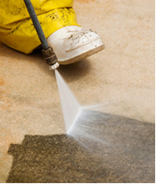
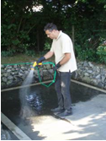
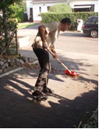

High pressure washer ... we advice against it!
Never use high pressure washers, because spraying under high pressure can damage the surface of the concrete. This roughens the surface and makes it more porous, and therefore susceptible to dirt and green deposits.

- The surface of a concrete product up close

What does the coating layer of our products look like?
It is interesting to know what the coating layer of our concrete products look like when greatly magnified.
This clearly shows where dirt accumulates and why specific treatments are recommended, while others are discouraged.
See the two close-up images of the coating layer of our Carreau products below:
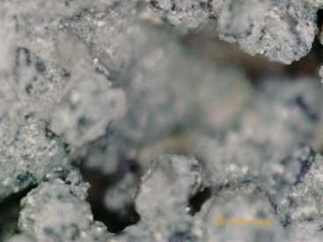
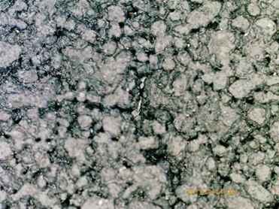
Figure 2: surface 200x magnified
Figure 1: surface 40x magnified

Dirt gets into these openings, which appear miniscule to the naked eye. Brushing and rinsing does not remove all of it. Ultimately, these spots gradually disappear as the pavement or terrace is used and through impact of climatic conditions.
Tar or paint stains, on the other hand, will not fade away. Contamination is most noticeable in light coloured tiles (e.g. Arduna, Gris Naturel, Big White, Grand Blanc, Latte...) and least noticeable in tiles that are washed out (Rockstone).
As with natural stone, most stains disappear through natural weathering.
We understand that not everyone can or is willing to wait for this to happen and in those cases case we recommend thorough cleaning by a specialist company
(e.g. Terrazza – www.terrazzamc.be).
- External contamination during or after installation
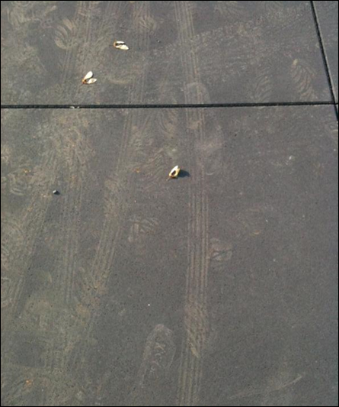
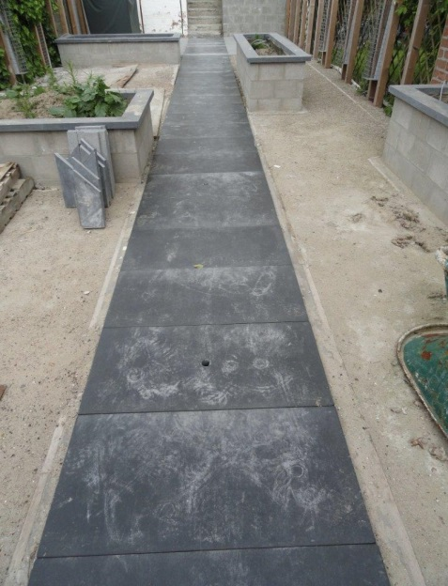
To avoid nasty stains after installation (e.g. footprints, wheelbarrow tracks, saw dust residues etc.). We recommend covering the yard during installation. It is important to remove the coverings again at the end of the day to allow the surface to breathe and to avoid efflorescence. Regular rinsing is recommended. If this is not done any remaining stains can be removed with a cleaning product, although they may not disappear completely. In that case, it’s best to rely on natural weathering (by climatic conditions) and use of the surface.

- Oil stains
Specialised oil removers can be bought from hardware shops (e.g. Lithofin Wax-Off, HG Super remover etc.). Always follow the manufacturer’s instructions for use. Quick response is required, however, because the longer you wait, the harder it will become to remove the stain.
- Grease stains
Specific products are available to fight grease stains. Always follow the instructions for use closely. If you have a little more patience, you will notice that most grease stains will disappear with the influence of climatic conditions.
- Other stains
You will find suitable products at hardware shops such as Lithofin, HG and Techniseal for removing other stains such as paint, tar, soot, etc.
- Green deposits

Green deposits are the result of algae and/or moss growing on a damp surface and are no indication of a product of inferior quality. All materials (even metal and glass) that are kept outside for extended periods of time can exhibit this sort of green deposit. A product that is placed on a wet surface and/or in a moist and shady environment will naturally turn green faster than a product that is kept in a dry, sunny place.
Green deposits can be easily removed in most cases by treating (spraying or rinsing) the paving with an anti-moss product 2 or 3 times a year. Always follow the instructions on the packaging of these products.
Hardware shops stock products for the removal of algae and moss and to inhibit new growth of algae (e.g. HG green deposit remover, Lithofin Allex, etc.).
We recommend testing a small area in an inconspicuous place first.
A frequently asked question is whether Rockstone and Cliffstone products are more susceptible to green deposits because of their rougher surfaces. The susceptibility of a surface to green deposits depends to a large extent on the porosity of the stone, which in turn is determined by how sealed the surface is (holes), and the hardness of the stone granulates.
Because both Rockstone and Cliffstone products have an optimum sealed structure and are made with the best and hardest stone aggregates, we can guarantee low porosity and minimal water absorption. This also means that these materials tend to gather less moss.
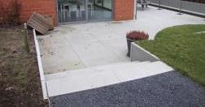
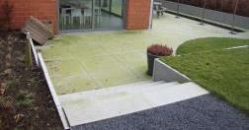

- Lichens
Lichens are not really plants, but rather a society of fungi and algae. The two components form one functional unit. They grow close to the surface and can therefore only be removed by mechanical means.
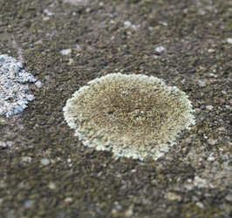
Diploicia canescens -
Lichen or Moss accumulations

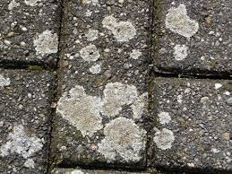

New concrete is too basic for lichens as they prefer an acidic or lime-rich (pH ± 11) surface. It therefore usually takes up to five years (when the pH value has increased to ± 8) before the first lichens appear.
Lichens can be removed by:
1. Treatment with hot, or even boiling water, or (even better) by steam-cleaning with as high a temperature as possible.
2. Chemical treatment with special products (not with standard anti-moss products) e.g. AGO Quart or Biomos.
Never use a pressure washer because it could irreparably damage the coating of the tiles or pavers.

- White spots: Efflorescence?

If you wet a surface and white spots and stains disappear or become hard to see you are dealing with efflorescence. Efflorescence is an effect which arises under certain climatic conditions, and is caused by a film of water covering concrete.
Calcium released during the hardening of cement dissolves in water and condenses on stone as it evaporates. Contact with airborne CO₂ turns this lime into a white calcium carbonate deposit, which crystallises on the surface.

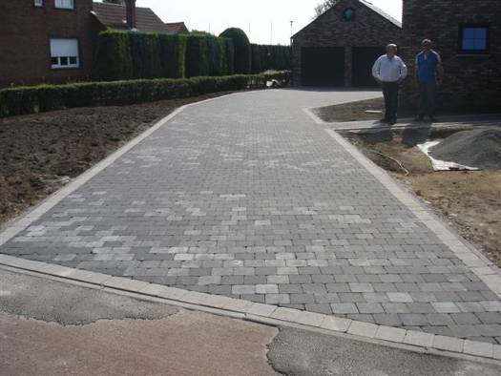
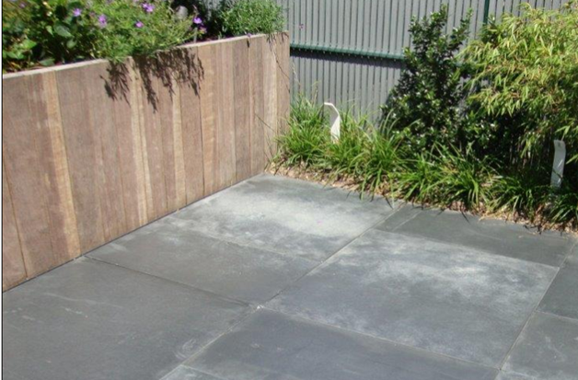

This is a natural phenomenon that can occur with any cement-based product, and resembles the saltpetre that can appear on other natural materials such as the outer walls of buildings. Efflorescence disappears the same way it appears. Frequent rainfall and use of the paving will cause this phenomenon to quickly disappear.
If these deposits are an eyesore you can buy products such as Lithofin, HG Deposits Remover, etc., from your local hardware shop to remove them. Carefully read the instructions because incorrect application may change the texture and colour of your paving.
We recommend testing a small area in an inconspicuous place first.
Treatment with acid-based products is not recommended because that may permanently damage the coating.
Please note that we do not accept any responsibility for
complaints following incorrect application of these products.

- Cleaning agents summary table

Type of stain | Cleaning agent
Dust and normal dirt | Neutral soap
Oil stains | E.g. Lithofin Wax-Off, HG Super remover, Techniseal Cleaner-Degreaser**
Grease stains | E.g. Lithofin Wax-Off, HG Super remover, Techniseal Cleaner-Degreaser**
Green deposits | E.g. Lithofin Allex, HG green deposit remover, Techniseal moss remover, Zeptreet 100, Greenaway (Van Meerbeek) or a diluted bleach solution
Rust stains | HG rust and other oxidation (stain) remover, Techniseal rust remover, Lithofin Rost-Ex
Persistent stains: paint, tar, tyre marks and chewing gum | E.g. Techniseal stripper, HG oil & grease stain absorber,
Cement residue, stabilisation marks | E.g. Techniseal cement residue remover⁽¹⁾ Lithofin or HG cement residue remover⁽¹⁾ **
Stains caused by plants, silt and garden waste  general surface dirt | Lithofin MN Outdoor Cleaner

** These products must not be used on Mega Smooth products as they could damage the impregnated protective layer
⁽¹⁾ Please Note: These products could affect the appearance of your paving!
More information is available at: www.techniseal.com - http://uk.hg.eu/index/home
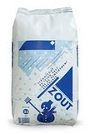
- Frost resistance
All our paving products are frost and weather resistant. Cast tiles from our Bradstone and Mega Smooth collection are not resistant against de-icing salts.
Other products from our Stone & Style pavement ranges are resistant against de-icing salts. Please note: When using de-icing products, make sure accumulated de-icing salt
is not left for extended periods of time, as this may cause damage to the surface.

- Preventative treatment

There are many products available to impregnate or seal your concrete products to reduce the penetration of all kinds of pollution or to facilitate cleaning of your surface. When using these products, the surface of your pavement is 'sealed' to a greater or lesser extent, which means that weather influences and contamination are less likely to act on the concrete surface.
Over time the protective effect (of these products) reduces, so impregnation should be applied regularly.
There are many products from companies such as Lithofin, HG or Techniseal available at hardware shops for the protection of tiles and pavers. These products differ from each other in the extent in which they seal a surface, the degree of 'gloss' created through application and the manner in which it should be applied.
These products should always be applied to a clean and dry surface, while the outside temperature is at least 15 °C.
Please note: efflorescence (see p.8) becomes sealed in when impregnation is applied and it will become very difficult or impossible to remove.
Always carefully follow the instructions of the manufacturer.
We recommend testing a small area in an inconspicuous place first. Please note that we do not accept any responsibility for complaints following incorrect application of these products.
For thorough cleaning, we recommend that you contact a specialist company
(e.g. Terrazza – www.terrazzamc.be).

- Maintenance of Mega Smooth products
Cleaning:

- During the production process each tile is lightly impregnated. This treatment is not a guarantee against contamination, however. Be sure to clean the tiles immediately after a spill. Remove normal dirt with clean water.

- When it comes to cleaning agents we recommend using ordinary household products (e.g. a neutral all-purpose cleaner). Acidic products or products that contain linseed oil could cause permanent stains following prolonged contact with the surface. The use of these products is not recommended.

- Never use a pressure washer as it may damage the pavement surface beyond repair.

- Do not brush in new sand as is recommended with other products as the sand could cause scratches or if the sand is polluted it could even cause stains on the tiles.

- DO NOT use acidic products to remove efflorescence as these products could harm the tiles. It is recommended to use a product such as Techniseal-Shampoo to treat the tiles once.
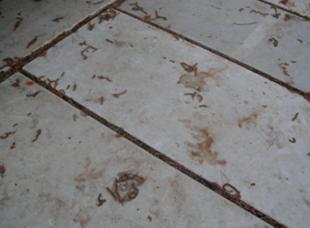
- Lithofin Outdoor Cleaner provides good results against natural pollution e.g. soil, leave or other natural material imprints.

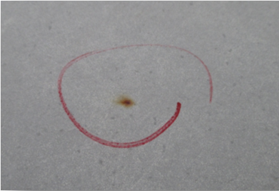

- Small rust spots are caused by the natural raw materials used in the products. Products against this are also available in hardware shops (e.g. Lithofin Röst-Ex).

Most stains disappear under the influence of weather conditions:
If other works are to be done around the terrace after installation of Mega Smooth tiles we recommend protecting the tiles with a moisture-free material (to prevent stubborn stains). It is important to remove this protective material at the end of each day as extensive covering may lead to efflorescence.
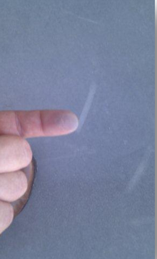
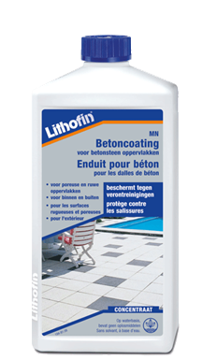
Recoating:
If the impregnation starts to fade away after some time and the tile begins to 'dust', you can apply a new layer. We recommend using Lithofin MN Concrete Coating, which is the same product used during the manufacturing process.
First clean the tiles thoroughly. Make sure to follow the manufacturer's instructions.
Please note: any remnant spots of dirt or efflorescence will be sealed in with this impregnation process and it will become very difficult or impossible to remove afterwards.
De-icing salts:
Our Mega Smooth products are resistant to frost, but not to the 'effects' of de-icing salt.
De-icing salt reduces the freezing point of water by mixing with the water present (ice or snow), which forms slush. Since this slush has a lower freezing point than water it will take longer to freeze, causing the ice to defrost.
The lowering of the freezing point causes the surface of the tile itself to continue to cool to extremely low temperatures. This 'temperature drop' may cause serious damage to the surface of the tile (= erosion of the cement layer).
Sand is not a viable alternative as it could cause scratching or stains.
If you are only dealing with snow we recommend carefully removing it with a broom or shovel. If you should decide to use de-icing salt, it is recommended to use very small quantities and to prevent accumulation. Please note: this is at your own risk.

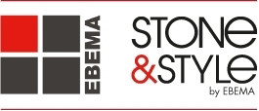

We wish you lots of garden pleasure ...

© 2015 – EBEMA NV - All rights are reserved. It is prohibited for anything in this publication to be copied, stored in a data file or made public, in any way or form, be it electronic, mechanical, by means of photocopies, recording or any other method without written permission in advance from the publisher.

